- Šta je klima?
________________________________________________________________________________________________________________________________________________
- Šta je vrijeme?
________________________________________________________________________________________________________________________________________________
- Nabrojati klimatske faktore.
________________________________________________________________________________________________________________________________________________
- Nabrojati klimatske elemente.
________________________________________________________________________________________________________________________________________________________________________________________________________________________
- Šta je vazdušni pritisak?
________________________________________________________________________________________________________________________________________________________________________________________________________________________________________________________________________________________________
- Šta su vjetrovi?
________________________________________________________________________________________________________________________________________________________________________________________________________________________________________________________________________________________________

- Šta su monsuni? ________________________________________________________________________________________________________________________________________________________________________________________________________________________
- Šta je magla?
________________________________________________________________________________________________________________________________________________________________________________________________________________________________________________________________________________________________________________________________________________________________________

- Nabrojati klimatske pojaseve.
_______________________________________________________________________________________________________________________________________________________________________________________________________________________________________________________________________________________________
- Napišite sve što znate o umjerenom pojasu.
________________________________________________________________________________________________________________________________________________________________________________________________________________________________________________________________________________________________________________________________________________________________________________________________________________________________________________
- Koji su klimatski tipovi u žarkom pojasu?
________________________________________________________________________________________________________________________________________________________________________________________________________________________
- Koji su klimatski tipovi u umjerenom pojasu?
________________________________________________________________________________________________________________________________________________________________________________________________________________________
- Napisati Kepenovu klasifikaciju klimata na Zemlji.
________________________________________________________________________________________________________________________________________________________________________________________________________________________________________________________________________________________________
- Šta je pustinjska klima?
________________________________________________________________________________________________________________________________________________________________________________________________________________________________________________________________________________________________________________________________________________________________________________________________________________________________________________
- Šta je planinska klima?
________________________________________________________________________________________________________________________________________________________________________________________________________________________________________________________________________________________________________________________________________________________________________
- Šta su pasati?
________________________________________________________________________________________________________________________________________________________________________________________________________________________________________________________________________________________________________________________________________________________________________________________________________________________________________________
- Nacrtati šemu opšte cirkulacije atmosfere.

- Šta su morske mijene i kako nastaju?
________________________________________________________________________________________________________________________________________________________________________________________________________________________________________________________________________________________________________________________________________________________________________________________________________________________________________________________________________________________________________________________________________________________________________________________________
- Šta su morske struje, i koji su uzročnici njihovog nastanka?
________________________________________________________________________________________________________________________________________________________________________________________________________________________________________________________________________________________________________________________________________________________________________________________________________________________________________________________________________________________________________________________________________________________________________________________________________________________________________________________________________________________________________________________________________________________________________________________________________________________________________________________________________________________________
- Prema načinu postanka morske struje mogu biti:
________________________________________________________________________________________________________________________________________________________________________________________________________________________________________________________________________________________________
- Na karti unijeti morske struje Tihog okeana.
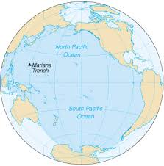

- Na karti unijeti morske struje Atlantskog okeana

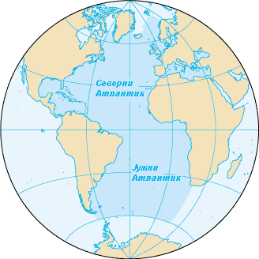

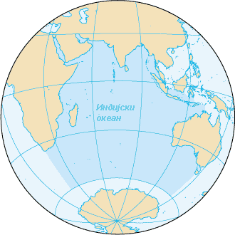
- Na karti unijeti morske struje Indijskog okeana.

- Na karti unijeti morske struje Sjevernog ledenog okeana.
